Day 45

DIY

DIY Questions:

John has recently joined an organization. His manager has given him the task of carrying out some git operations. Assist John to perform the following git operations.

Tasks:

1.Create a working directory

2.In the working directory, create a git repository

3.Create a file in the working directory

4.Now add the file to the git staging area

5.Check the git status

6.Commit the file to the git repository

7.Check the files in the git repository

8.Check the Commit id generated and index number generated.

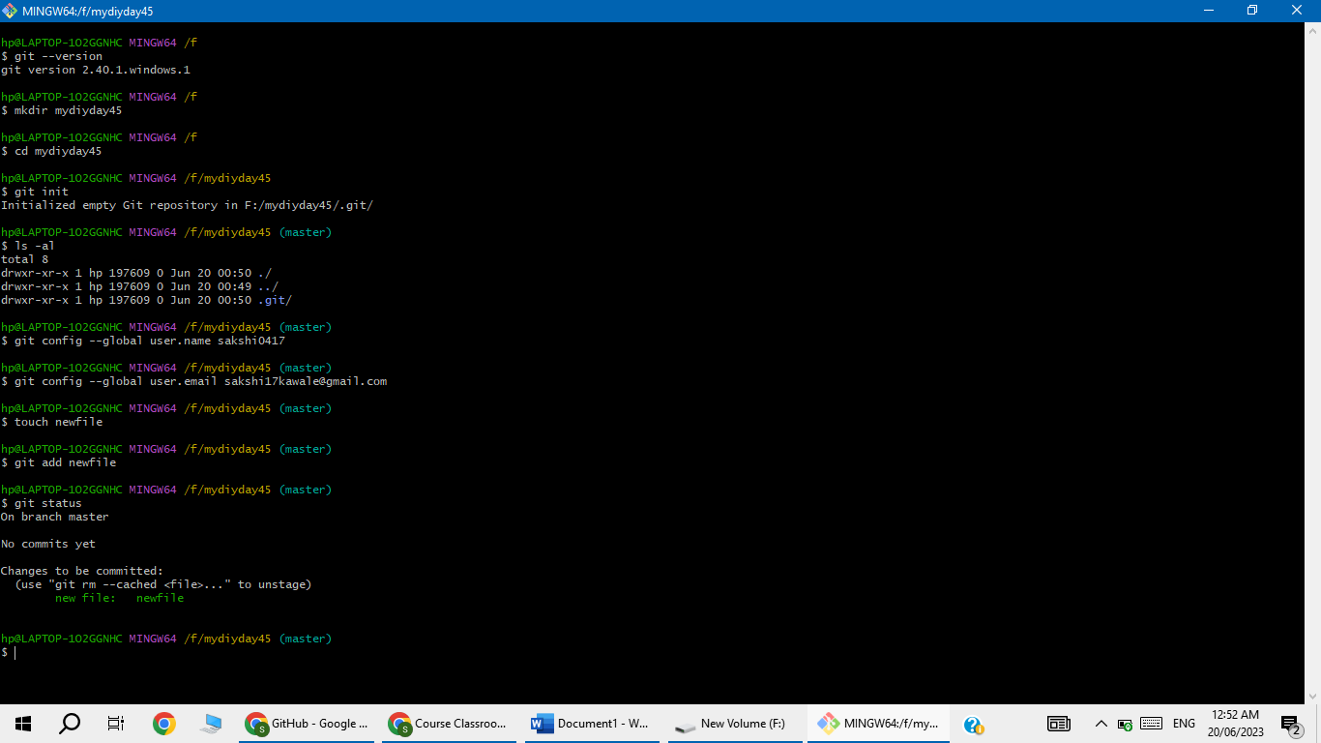

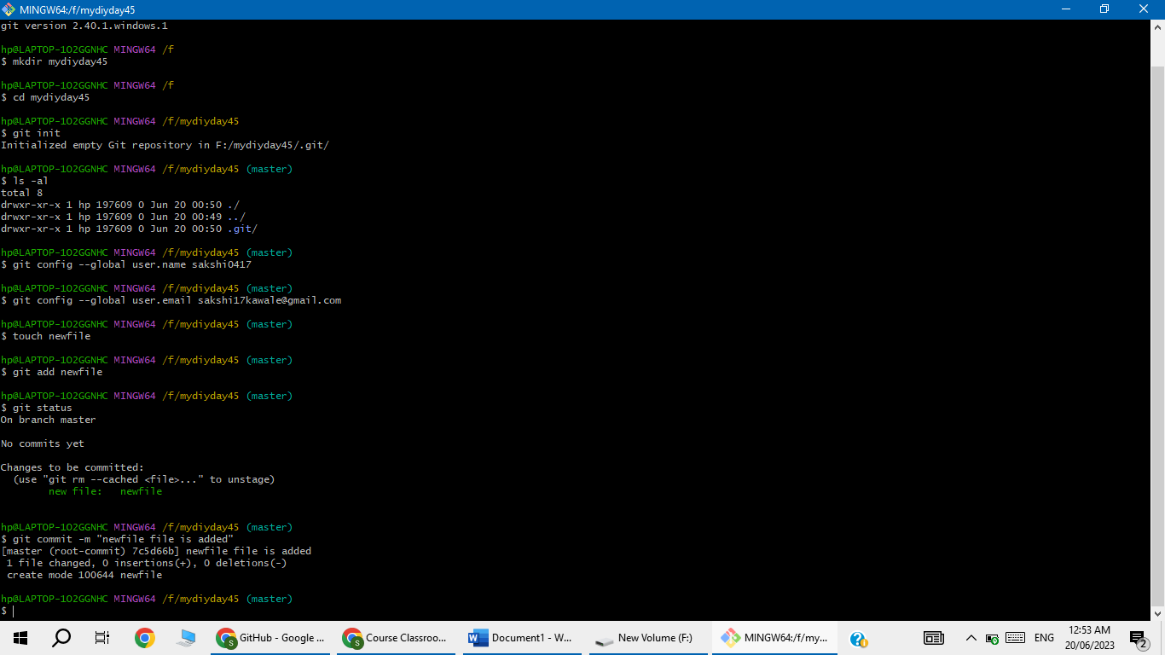

Now newfile is also available in repository

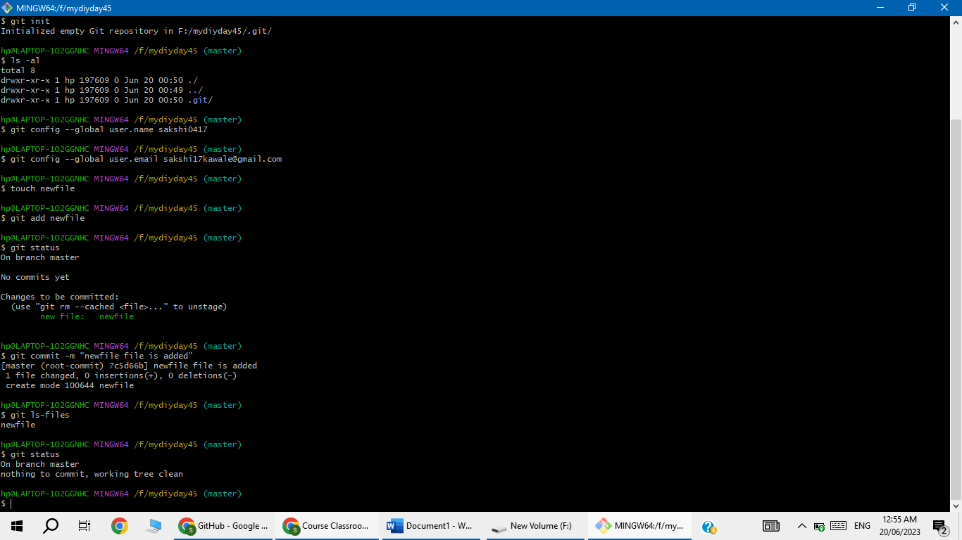

Now ,Check the Commit id generated and index number generated

